**Post-processing of Atomistic Simulation Data using Python and setting up a Deep-Learning Model for Inverse Design of 2D Materials Based Heterostructure**

**INTRODUCTION**

The introduction of two-dimensional (2D) materials and their integration with Artificial Intelligence (AI) has attracted widespread interest due to their unique features and prospective applications. Atomistic simulations are critical for understanding the properties and behavior of these materials on an atomic scale. However, getting relevant insights from large amounts of simulation data remains difficult. Furthermore, an inverse designing deep learning model to predict properties of 2D material-based heterostructures through given parameters has been developed.

**PROJECT OBJECTIVES**

* Develop a Python-based code for post-processing and analysis of atomistic simulation data.
* Design and train a deep learning model capable of inverse design, predicting optimal 2D material-based heterostructure parameters for specific target properties.

**WORKFLOW**

WP1. Deep Learning Model for Inverse Design

* Design a deep learning model architecture (ANN) tailored for inverse design tasks, capable of mapping desired properties to material structures.
* Train the model using the curated dataset, and validate the model's predictive accuracy and generalizability through testing and comparison with experimental and simulation data.

WP2. Python-based Post-processing Module and Dataset

* Develop a Python code for atomistic simulation data, including format conversion, data cleaning, and organization.
* Utilize data visualization libraries (e.g., Matplotlib, Seaborn) to create plots and graphs for data analysis.
* Construct a dataset of 2D material-based heterostructures, encompassing a diverse range of material combinations and properties.

**EXPECTED OUTCOMES**

* A robust Python-based program for efficient and comprehensive post-processing of atomistic simulation data.
* A trained deep learning model capable of accurately predicting optimal 2D material-based heterostructure parameters for specified properties.

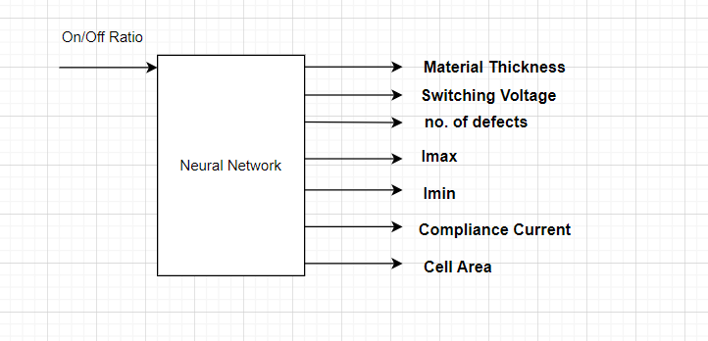

**RESEARCH SIGNIFICANCE**

This project addresses key issues in the inverse design of 2D material-based heterostructures. The suggested research provides a solution for determining material parameters based on Property demands by constructing a comprehensive program that incorporates Artificial Intelligence. The anticipated outcomes contribute to the efficient exploration of the vast design space of 2D materials, paving the way for novel applications of AI in various technological domains.

**CONCLUSION**

This research proposal describes an inverse design method for developing a deep learning model for 2D material-based heterostructures. The project's goal is to maximize the potential of 2D materials for advanced applications by creating a comprehensive AI model.